9:46 AM

C# is case-sensitive

Compile

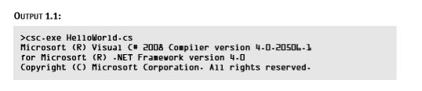

Run

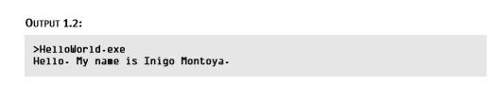

Identifiers:

In addition to the keywords defined in C#, developers may provide their own names. Programming languages refer to these names as identifiers since they identify constructs that the programmer codes. In Listing 1.1, HelloWorld and Main are examples of identifiers

**Naming**

Class: Pascal-based naming conventions -- ThisWordIsInPascalCase

Variable: Camel Case -- thisWordIsInCamelCase